

**CIRCUIT AND SYSTEM-2 LAB**

**Lab:09**

**INTEGRATOR USING IC741 OP-AMP**

**SUBMITTED BY : Tayyaba**

**SUBMITTED TO: SIR FAIZ ULLAH**

**REGISTRATION N0 : 19PWCSE1854**

**SECTION : C**

**DATE : 15.2.2021**

**Objective:**

To study the operation of the Integrator using op-amp and trace the output wave forms for sine and square

wave inputs.

**THEORY:**

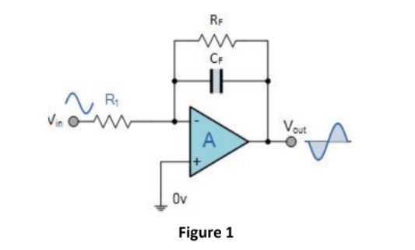

A circuit in which the output voltage is the integration of the input voltage is called an integrator.

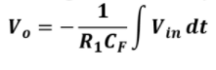

In the practical integrator shown in Figure 1, to reduce the error voltage at the output, a resistor RF is connected across the feedback capacitor CF. Thus, RF limits the low-frequency gain and hence minimizes the variations in the output voltage.

Integrator has wide applications in

1. Analog computers used for solving differential equations in simulation arrangements.

2. A/D Converters.

3. Signal wave shaping.

4. Function Generators.

**Equipment:**

1. Oscilloscope

2. AC Function Generator

3. Digital Multimeter

**Components:**

1. Resistors: 10kΩ, 22kΩ

2. Capacitor 0.1μF

3. Op-amp 741

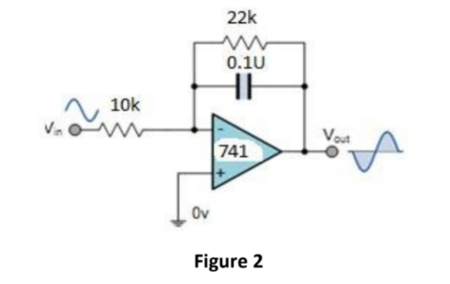

**PROCEDURE:**

1. Connect the components/equipment as shown in the circuit diagram Figure 2.

2. Switch ON the power supply.

3. Apply sine wave at the input terminals of the circuit using function Generator.

4. Connect channel-1 of CRO at the input terminals and channel-2 at the output terminals.

5. Observe the output of the circuit on the CRO which is a cosine wave (90o phase shifted from the sine wave input) and note down the position, the amplitude and the time period of Vin & Vo.

6. Now apply the square wave as input signal.

7. Observe the output of the circuit on the CRO which is a triangular wave and note down the position, the amplitude and the time period of Vin & Vo.

8. Plot the output voltages corresponding to sine and square wave inputs as shown in the Figure 3 below.

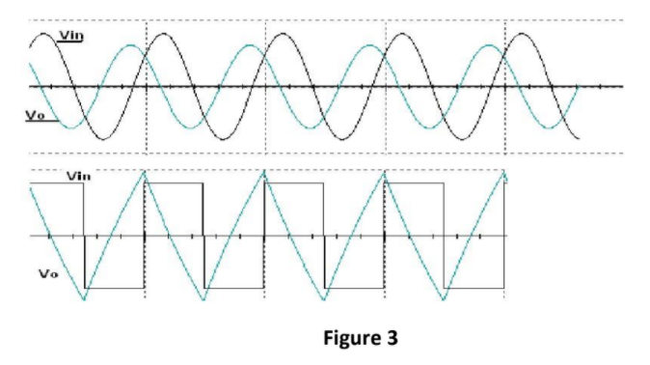

**Data Table:**

|  |  |  |  |  |
| --- | --- | --- | --- | --- |
| **Vin(p-p)** | **Frequency** | **Vo(Theoretical)** | **Vo(Experimental)** | **%Error** |
| **1.8 V** | **1 kHz** | **0.26 V** | **0.25 V** | **6.52%** |
| **2 V** | **1 kHz** | **0.41 V** | **0.33 V** | **3.91 %** |
| **1.7 V** | **2 kHz** | **0.77 V** | **0.095 V** | **-7.31 %** |
| **2.1 V** | **1.4 kHz** | **0.31 V** | **0.27 V** | **4.71 %** |
| **2.2 V** | **2.9 kHz** | **0.14 V** | **0.15 V** | **-4.16 %** |

